**Part 1. Harris Corner Detection**

1. Discuss the result of blurred images and detected edges between different kernel sizes of Gaussianfilter.

==========================================================================

Fig.1 和Fig2. 分別使用kernel size =5, 10 進行gaussian blur,

但因為kernel size大小差異較小，從此兩張圖較不容易觀察出差異，

故將kernel size調整成 300後，再比較與kernel size =5 :

|  |  |
| --- | --- |
|  |  |
| Fig1. Gaussian Blur (krenel size =5) | Fig2. Gaussian Blur (kernel size =10) |
|  |  |
| Fig3. Corner of Gaussian Blur  ( kernel size = 5) | Fig4. Corner of Gaussian Blur  ( kernel size = 200) |

裁取圖中線條較銳利的部分，以方便觀察。從Fig.3和Fig4，便能明顯看出kernel size的大小對於gaussian blur的影響: 大的kernel size會使邊線較模糊，反之小的kernel size則較為清晰。這是因為gauss blur 是以gauss kernel為中心點出發，每個kernel中央的值在經過gauss blur後，將會以其他非中央值的鄰居像素值作加權平均，故當kernel越大，每一個像素點會參考到的鄰居像素就越多，則就會越模糊。

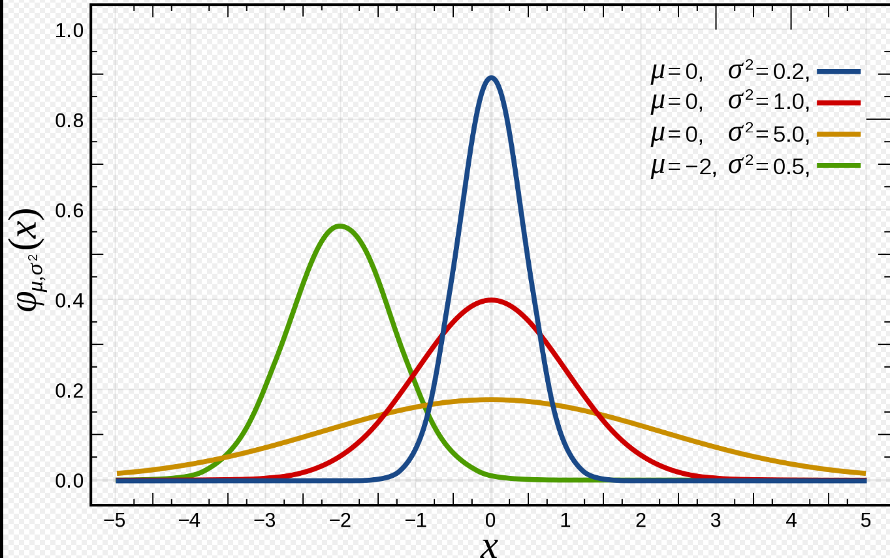

Fig.5 Gauss Disribution [1]

然而，不同鄰居像素，對kernel的影響程度並不一致:

從圖中的高斯分佈能夠看出，隨著σ的增加，左右兩端的值也會隨之增加。

代表著，和小σ相比，隨著σ的增加，較遠處像素對於中心點像素的影響能力來增加。

從下圖中，便能驗證上之結論:

|  |  |
| --- | --- |
|  |  |
| Fig5. Gaussian Blur σ=5, kernel size=5 | Fig.6 Gaussian Blur σ=0.5, kernel size=5 |

比較紅線圈起之處，σ越小，受到周遭像素的影響越小，故線條較銳利。

1. Discuss the difference between 3x3 and 30x30 window sizes of structure tensor.

=================================================================================

|  |  |
| --- | --- |
|  |  |
| Fig7 window size of structure tensor=3x3 | Fig8 window size of structure tensor=30x30 |

從兩張圖中，能夠很明顯看出，當window size越小，被視為edge的點就越多; window size越大，被視為edge 的點就越少。

這是因為

1. c. Discuss the effect of non-maximal suppression.

=================================================================================

|  |  |
| --- | --- |
|  |  |
| Fig9. Non-maximal suppression  (window size of structure tensor=3x3) | Fig10. Non-maximal suppression  (window size of structure tensor=30x30) |

1. d. Discuss the results of rotated and scaled image. Is Harris detector rotation-invariant or scale-invariant? Explain the reason.

**Part 2. Image Sensing Pipeline (ISP)**

1. **Why sensors need to use CFA (Color Filter Array) such as Bayer patterns to store color information? Explain how it works, too.**

因為感應器是由許多對部分範圍波長具有敏感性的光電二極體組成，測量該波長的強度，由於受到波長範圍的限制，每個二極體都只能夠針對單一顏色，並不能夠像人眼一樣直接辨識出不同顏色，故會透過不同的陣列組合(ex: Bayer patterns, RGBE filters,CYYM filter……等等)，獲取顏色強度訊息，市面上主要是紅、綠、藍三原色，但也有青、黃、洋紅的陣列組合，故視使用者希望呈現的視覺效果所訂。再針對不同的感測器陣列，設計不同的demosaic process，再將每個畫素的顏色轉換為我們所定義的顏色空間中的顏色。

1. **b. Give/Describe two other methods which can perform de-mosaicing and are not mentioned in the slide.**
2. Show the image results of each step as **p.13-14** in hw1_tutorial.pdf.

|  |  |  |
| --- | --- | --- |
|  |  |  |
| RAW | AWB | Demosaic |
|  |  |  |
| Color Correction | CIE XYZ to RGB | Tone Mapping |

d. In recent AI de-noising methods, in order to generate paired data for training, we will add synthetic noise to clean image on RAW domain instead of RGB domain. Explain the reason.

[1] <https://zh.wikipedia.org/wiki/%E6%AD%A3%E6%80%81%E5%88%86%E5%B8%83#/media/File:Normal_Distribution_PDF.svg>